**User Manual – Group 25**

Table of Contents

**1.Introduction** 3

**2.Login** 3

**3.Dashboard** 4

**4.Complete Course/Quiz** 7

**5.Friend System** 9

5.1 Friend Requests 10

5.1.1 Accepting a Friend Request 10

5.1.2 Declining a Friend Request 11

5.2 Friends 12

5.2.1 Adding a Friend 12

5.2.2 Removing a Friend 14

**6.Achievements** 15

**7.Global Leaderboard** 16

7.1 Changing the Ranking Factor of the Global Leaderboard 17

7.1.1 Changing the Ranking Factor to Achievements 17

7.1.2 Changing the Ranking Factor Back to Courses Completed 18

# **1.Introduction**

Our web application is built to allow users to take courses from IBM SkillsBuild with gamification features to provide a fun learning experience. This user manual is designed to help users understand and use the features of our web application effectively.

# **2.Login**

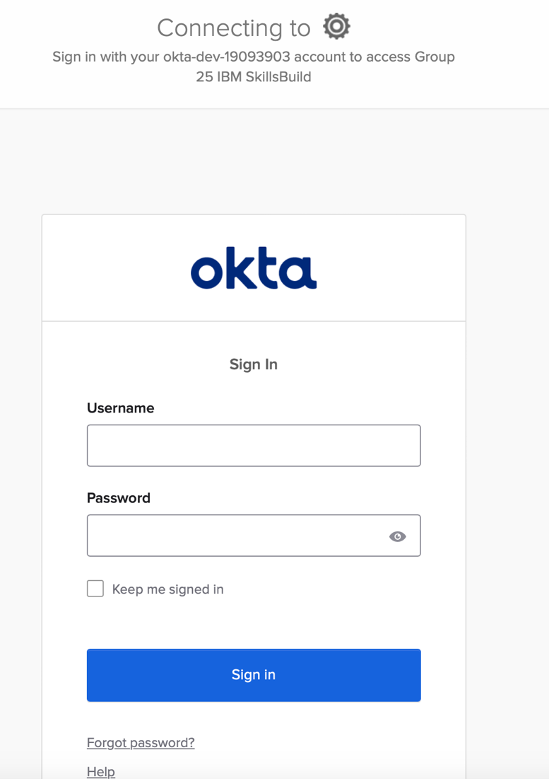

* The login has a simple username and password system and a feature to allow a user to stay signed in. The “Forgot password” feature is handled by Okta.

# **3.Dashboard**

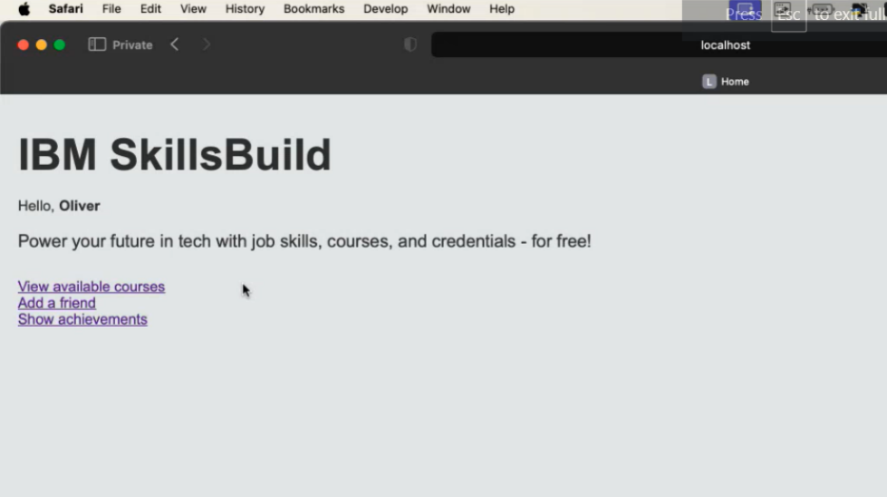

* The first page of the application is the “Home” page, with features that allow the user to view the available courses, add a friend or another user on the platform, and show the achievements each user has received.

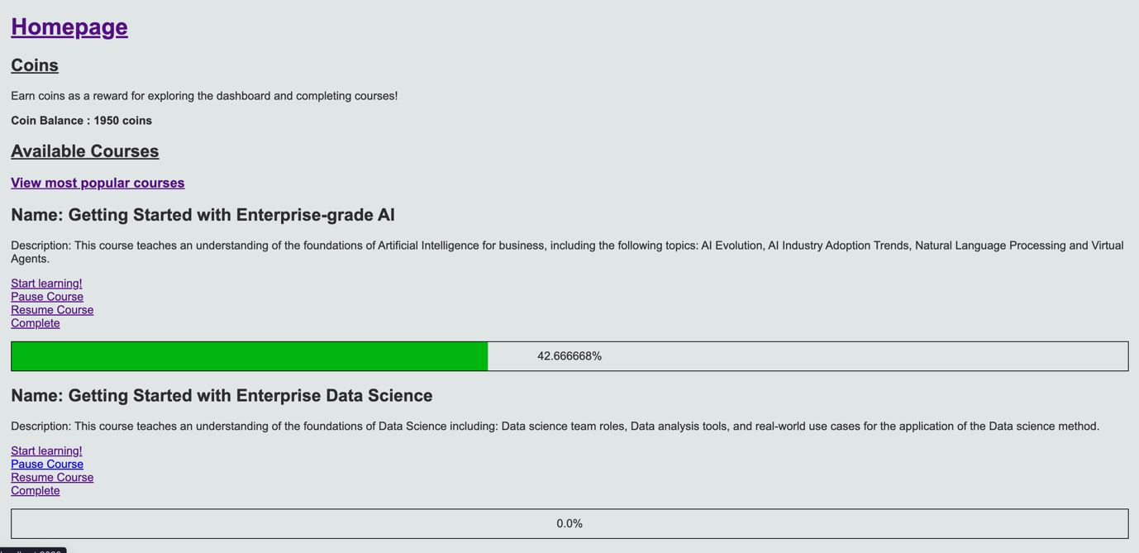

* The “View available courses” page shows a list of courses available to learn as well as a bar showing their progress. Each course then has 4 features.

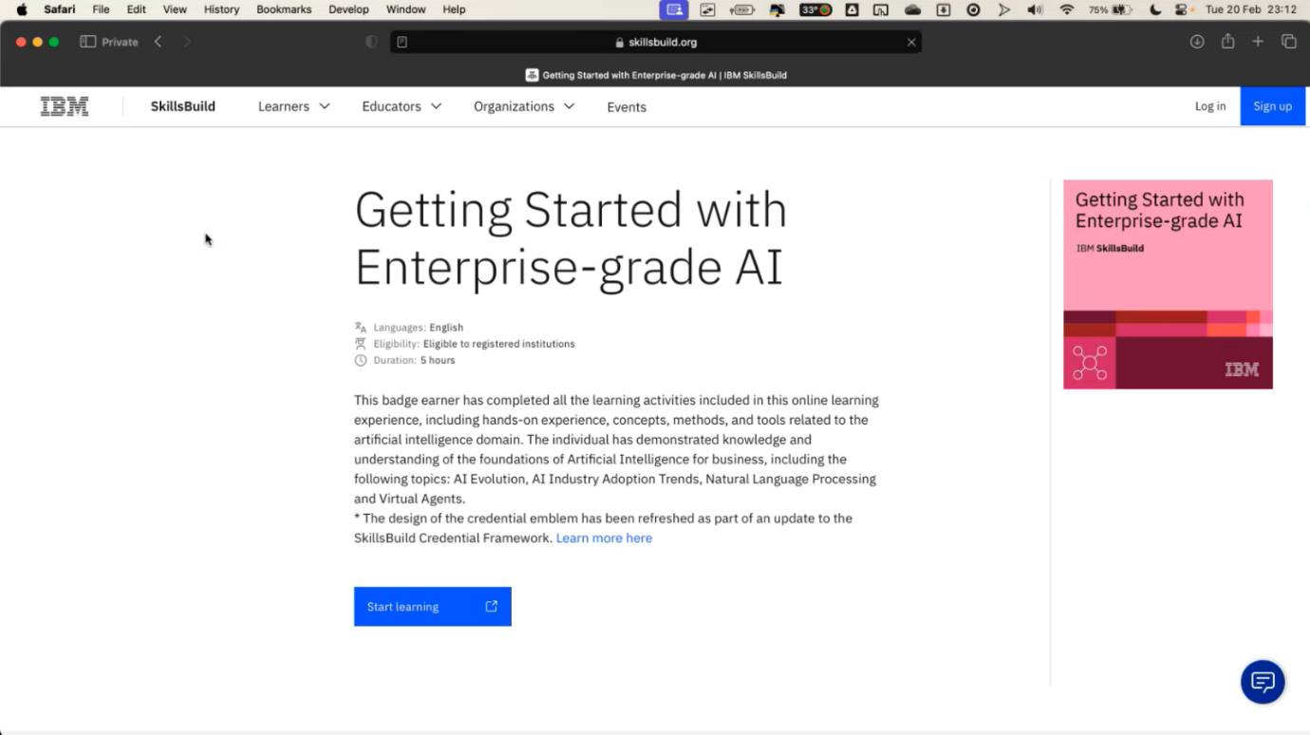

* The “Start learning” feature allows the user to start learning the course and link directly to the IBM website. The time the course is started is taken note of once the link is opened.

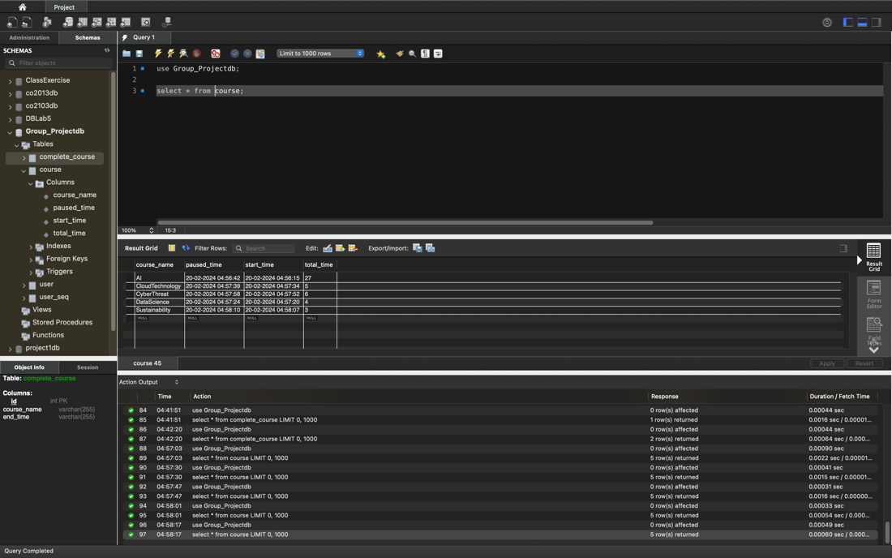

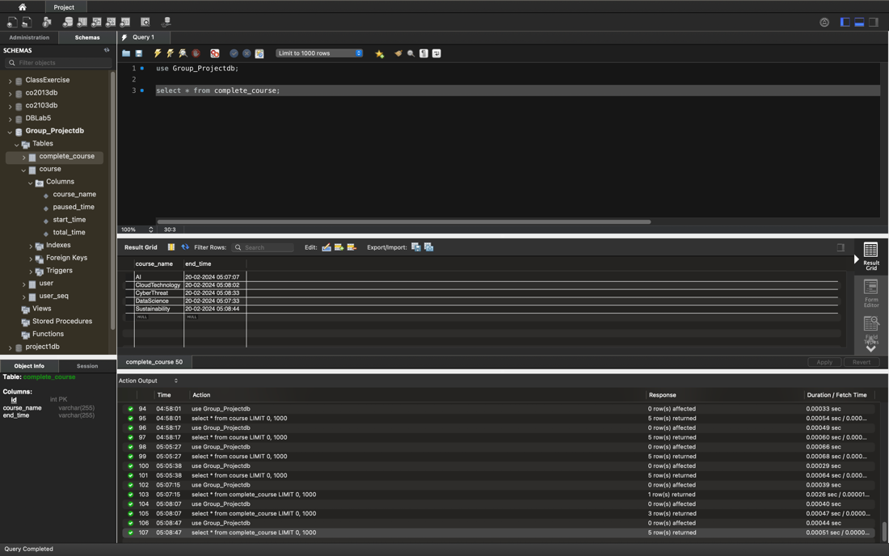

* The “Pause Course” and “Resume Course” features allow the user to pause and resume the course while they are learning, with the data on the time taken for each course stored in a database.

## Popular courses

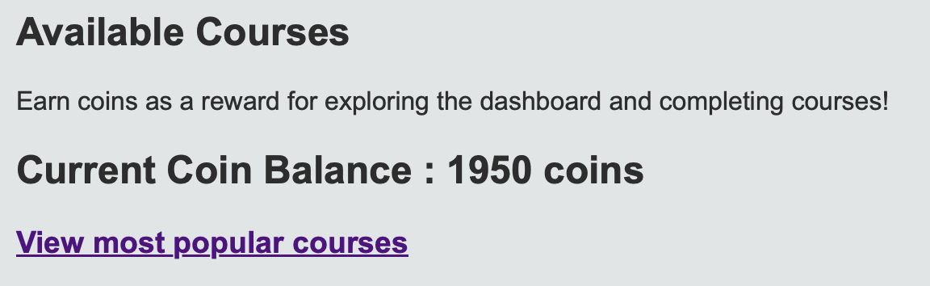Completing a course increments a counter, meaning that the total course completions is recorded. This data is then used to make a leaderboard of the most popular courses. To access this data, simply click the link in the course list.

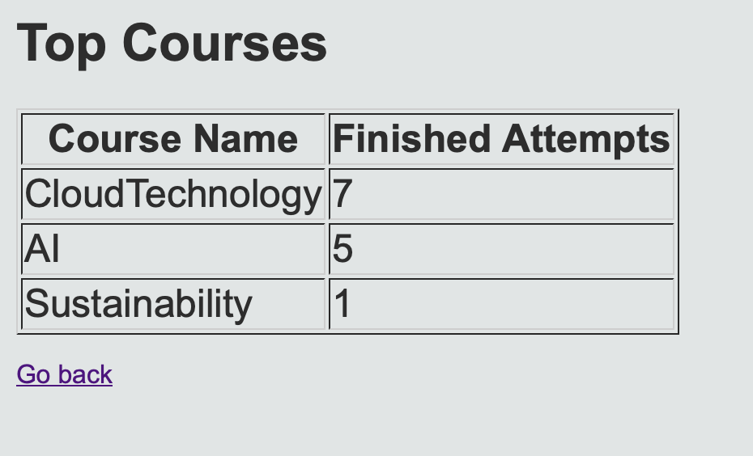This will display a table of the most popular courses.

## Reward System (Coins)



* At the top of the dashboard, there is a coin balance shown to the user that acts as a reward system.
* Exploring the dashboard, completing quizzes and completing a course, allows the user to increasingly collect coins that can then be used to unlock badges.

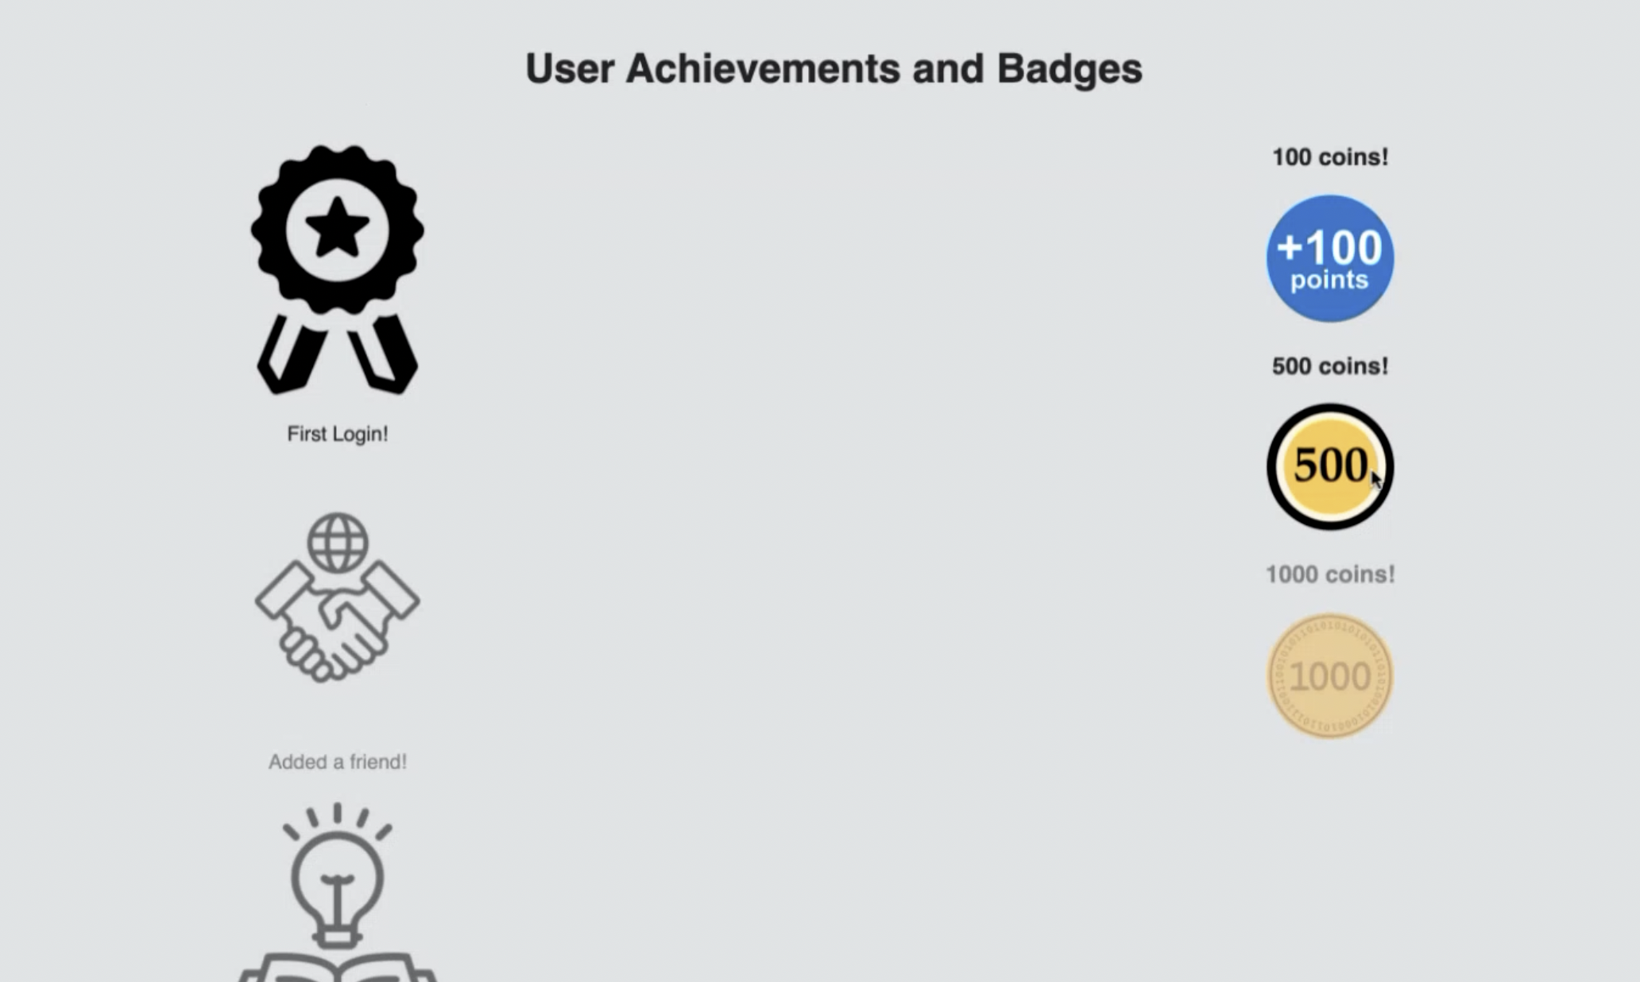

* This would then show on the Achievements page, and is a further incentive for the user to use the system and complete courses

# **4.Complete Course/Quiz**

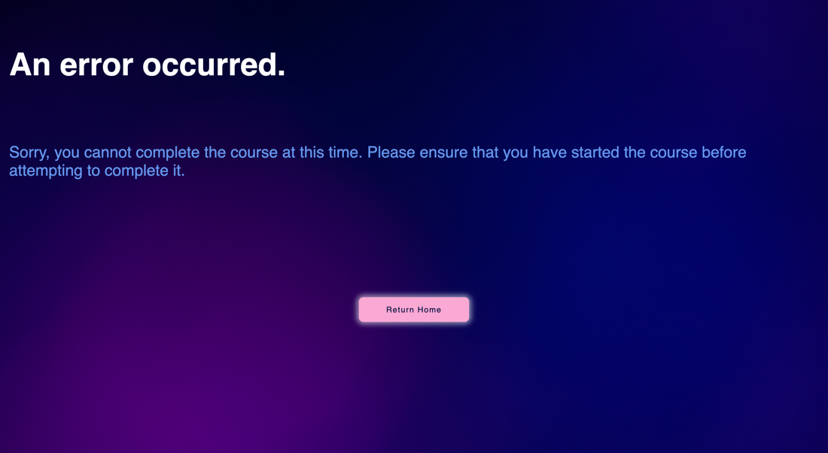

* If the user clicks the complete button before starting the course, they will be taken to an error page.

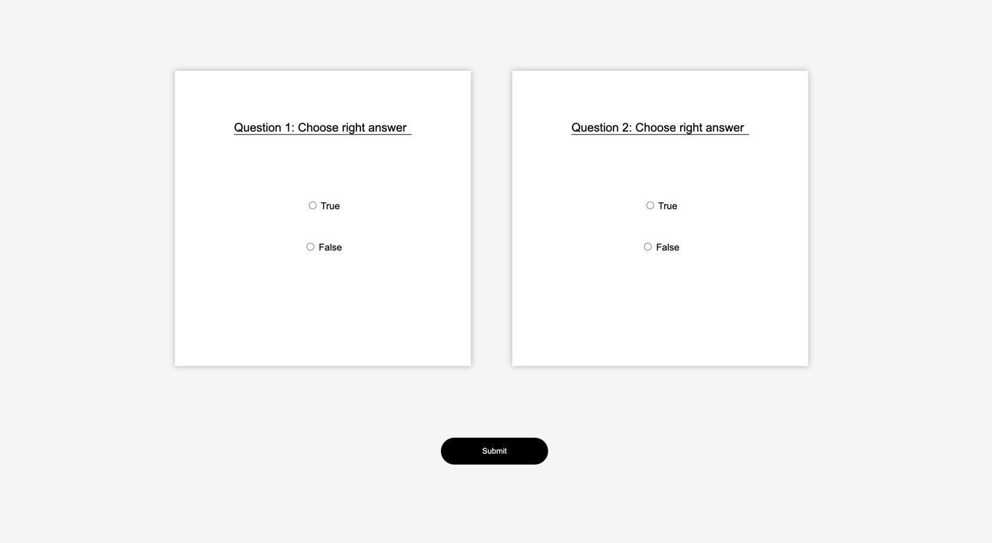

* The “Complete Course” feature allows the user to take a quiz on the course they have learnt. The user selects their options and submits the form.

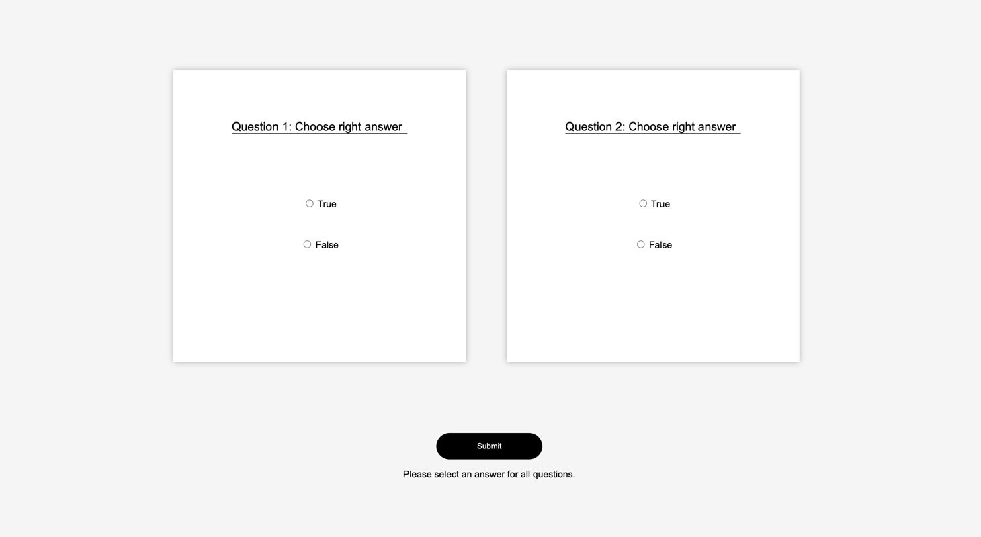

* When the user submits a quiz without selecting an option or when only one of the quizzes is submitted with a blank field, an error is explicitly displayed, and the user cannot proceed to the next page.

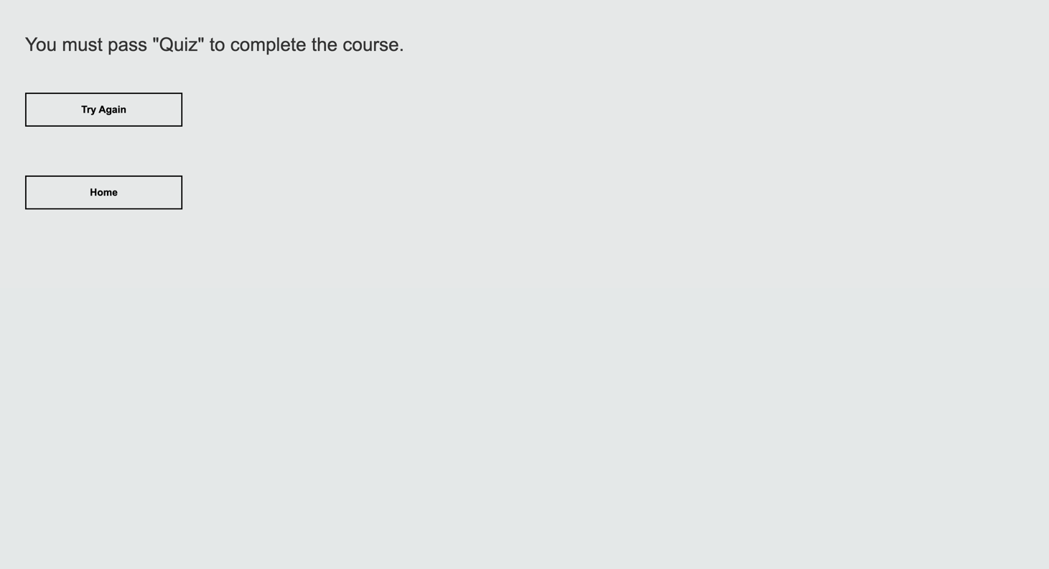

* If the user fails the quiz, the user cannot complete the course and is prompted to try again with the “Try again” feature.

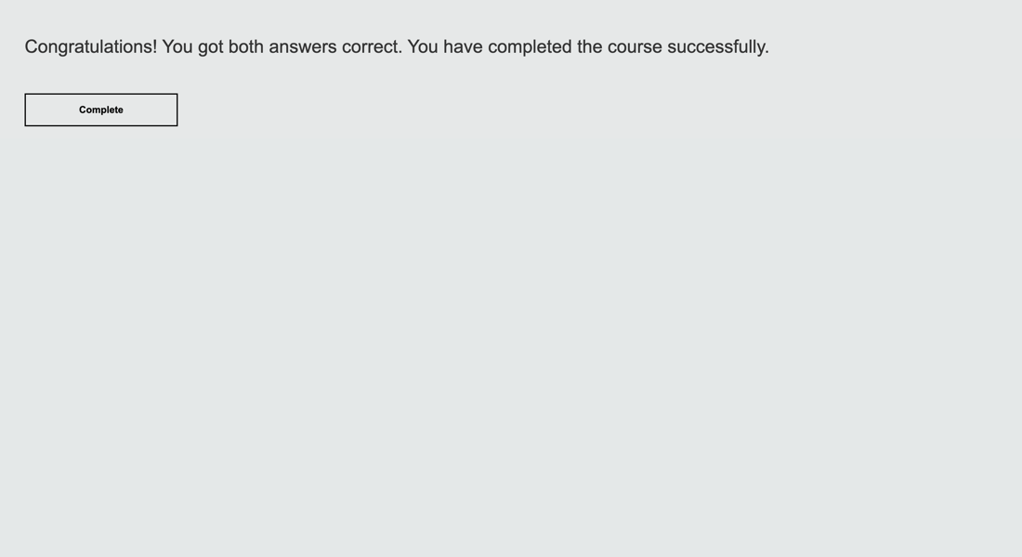

* If the user passes the quiz, the user completes the course.

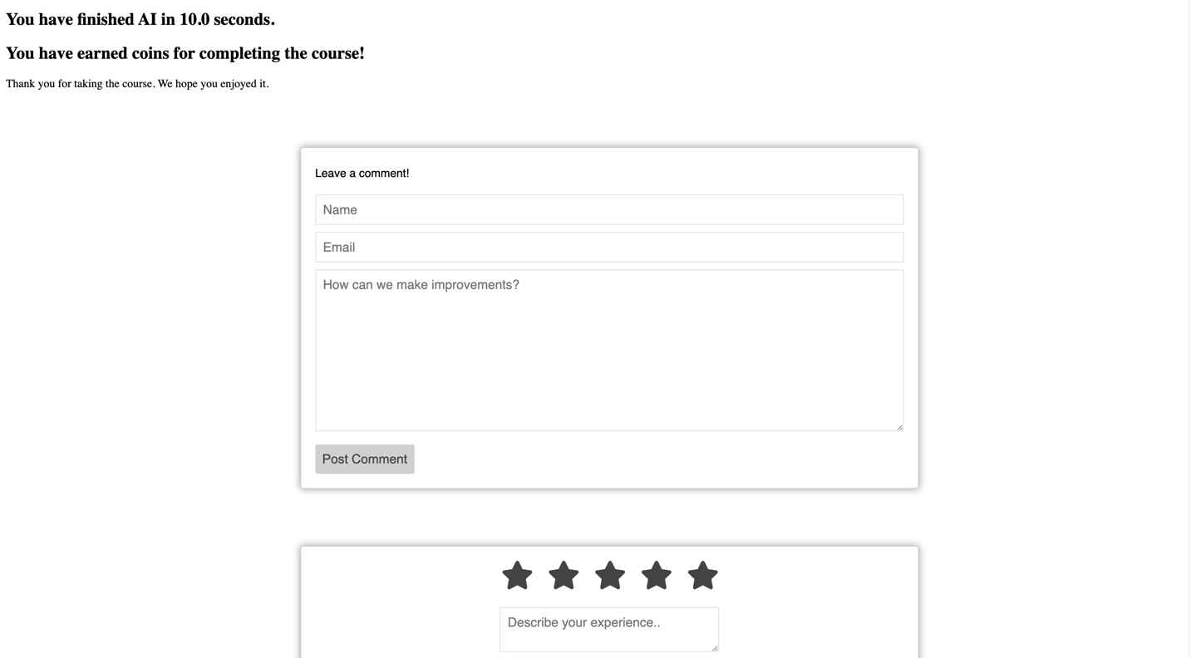

* The time it took to complete the course and a message will be displayed to inform the user that the course was completed.

**4.2 Commenting and Star Rating**

The user completes any one of the courses and is then directed to the commenting and star rating system outlines below.

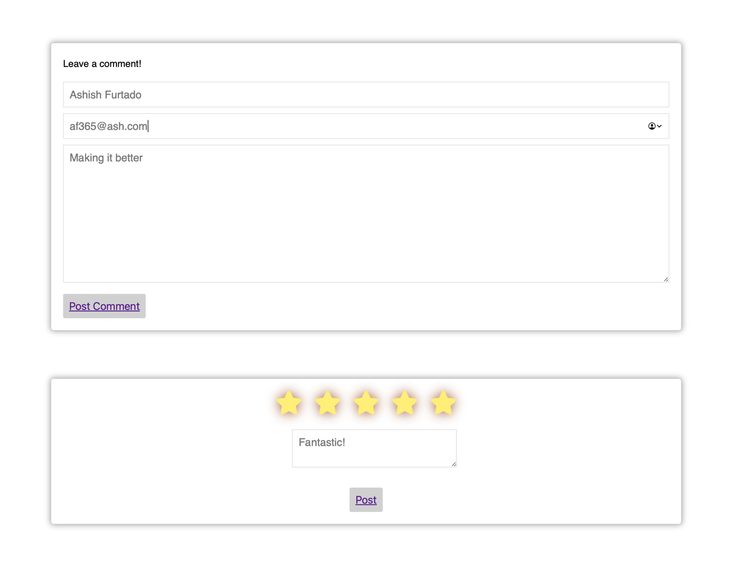

* Upon completion, the user is prompted to click a complete button which takes them to the comment and star rating system page, where they can leave a comment to suggest improvements and rate the course.
* Once posted, the user will be redirected to the course list page (3.)
* Entering an invalid email will result in not being able to submit.
* Alternatively, the user can opt to not leave a comment or rating and press the return home button located on the bottom.

# **5.Friend System**

You will be redirected to your ‘Friends’ page (Figure 5.2) when you click on ‘ADD A FRIEND’ (Figure 5.1) link on the home page/ dashboard. There you can see a list of friends in addition to a list of friend requests and an input box to add a new friend.



Figure 5.1

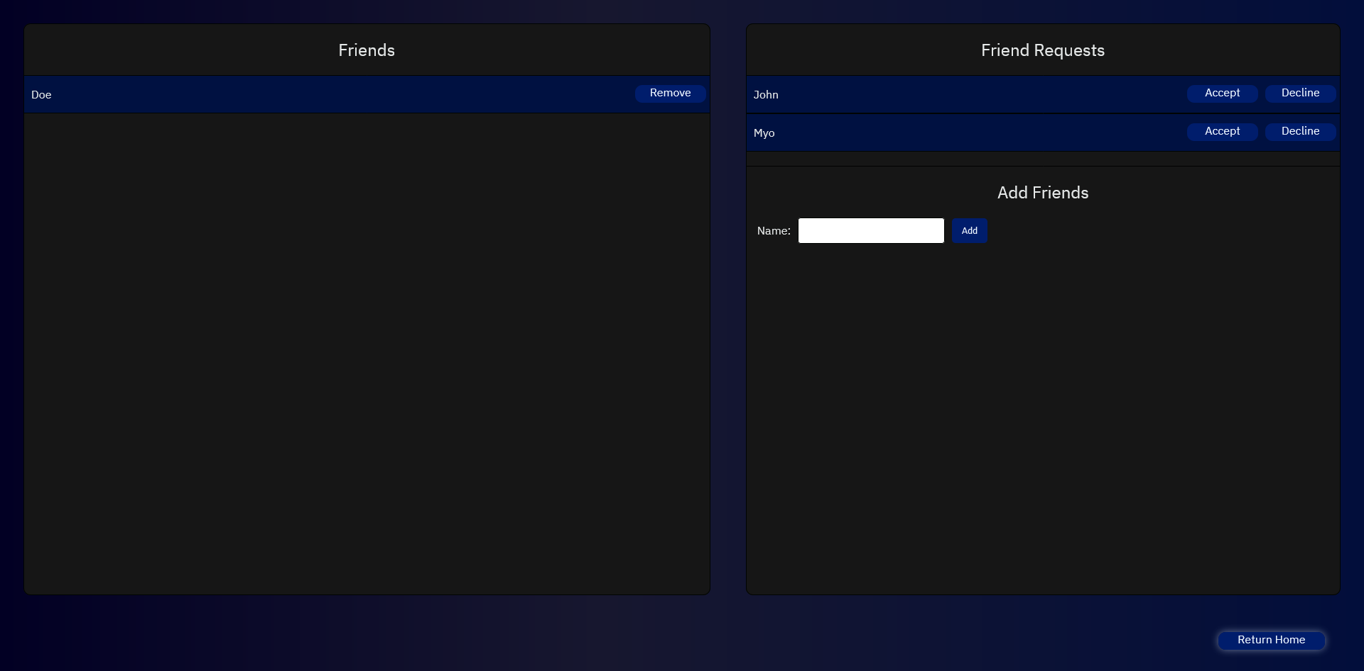

Figure 5.2

## 5.1 Friend Requests

On your ‘Friends’ page, you can see a list of friend requests on the right; you can see the name of the user who sent the request together with two buttons: ‘Accept' & ‘Decline’.

### 5.1.1 Accepting a Friend Request

To accept a friend request, follow these steps:

* Click on the ‘Accept' button.
* The user (sender) will now disappear from your friend request list and appear on your friend list.

Figure 5.3



Figure 5.4

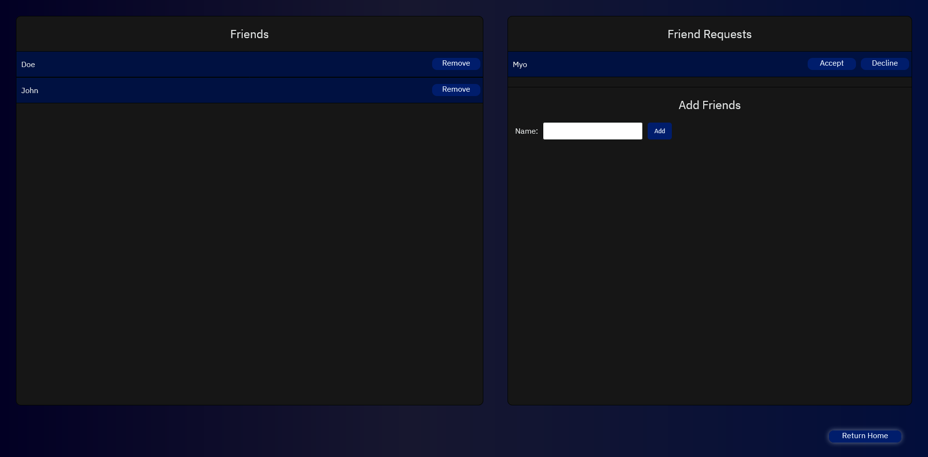

### 5.1.2 Declining a Friend Request

To decline a friend request, follow these steps:

* Click on the ‘Decline' button.
* The user (sender) will now disappear from your friend request list.

Figure 5.5



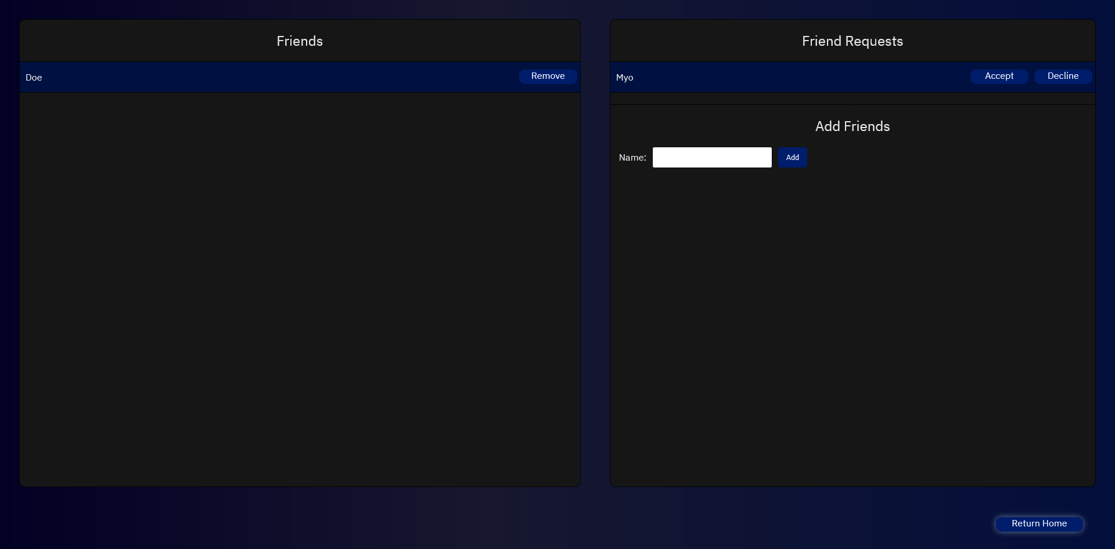

Figure 5.6

## 5.2 Friends

On your ‘Friends’ page, you can see a list of friends on the left; you can see the name of the user who you are friends with together with a button, ‘Remove’. On the right side below friend requests, you can see an input and ‘Add’ button.

### 5.2.1 Adding a Friend

To add a friend (send a friend request), follow these steps:

* Enter the username correctly in the input box (case sensitive).
* Then click on ‘Add’ button.
* If successful* the user you added will receive a friend request from you and see it the next time they check their ‘Friends’ page.

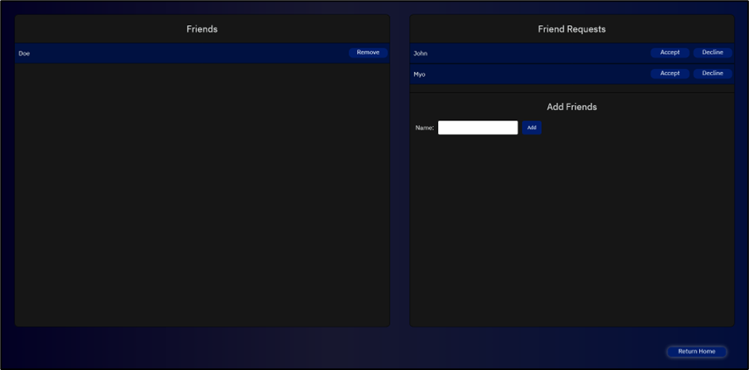

Figure 5.7

*In unsuccessful cases, you will be able to see the corresponding error message.

The unsuccessful cases are outlined below :

* The user does not exist.
* You tried to add yourself.
* You are already friends with that user.
* You have received a friend request from that user.
* You have sent a friend request to that user.

In Figure 5.8, you can see the example of an unsuccessful case when you try to add a user that does not exist.

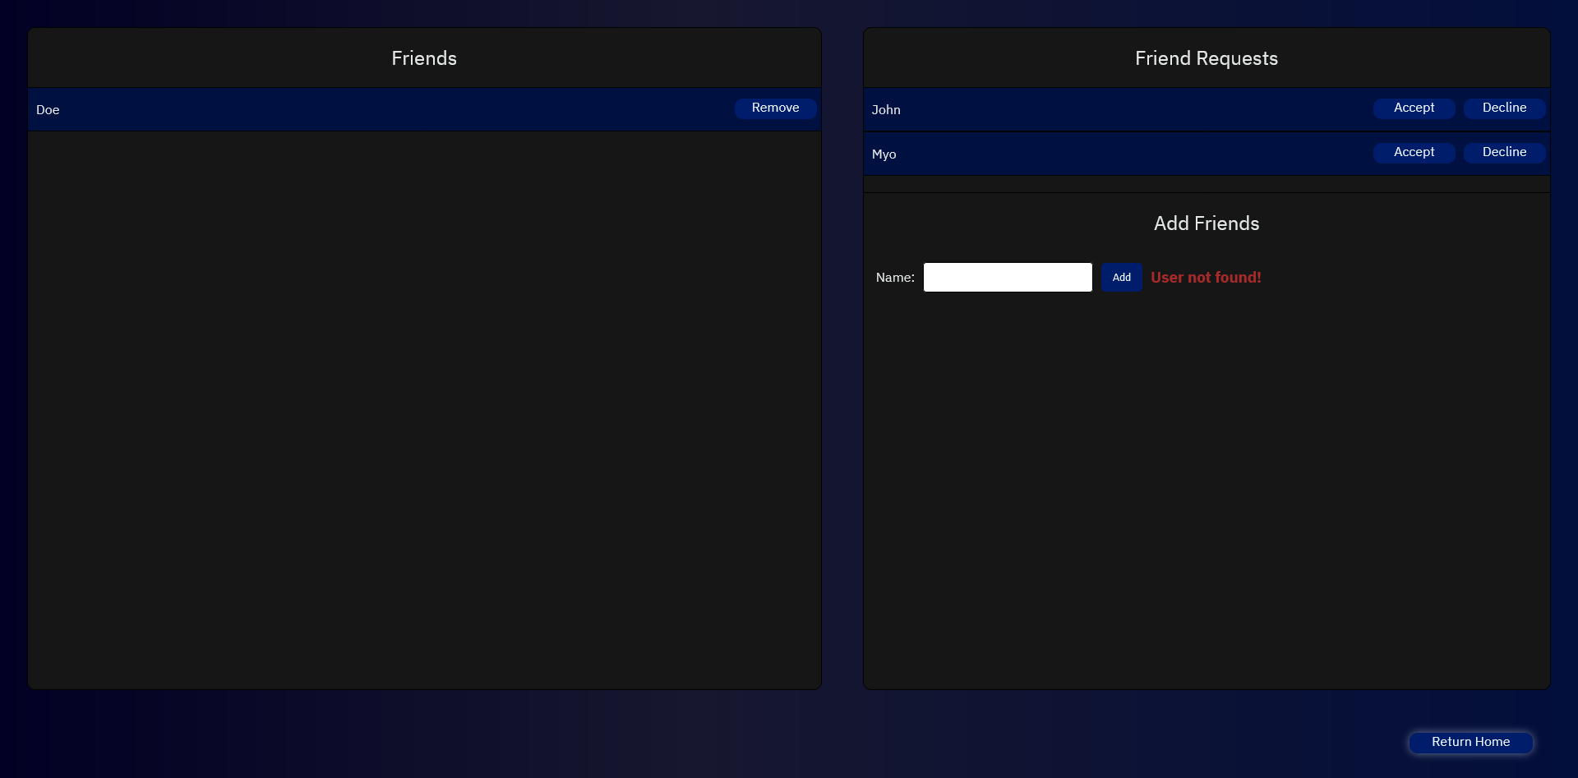

Figure 5.8

### 5.2.2 Removing a Friend

To remove a friend, follow these steps:

* Click on the ‘Remove' button.
* The user will now disappear from your friend list.

Figure 5.9



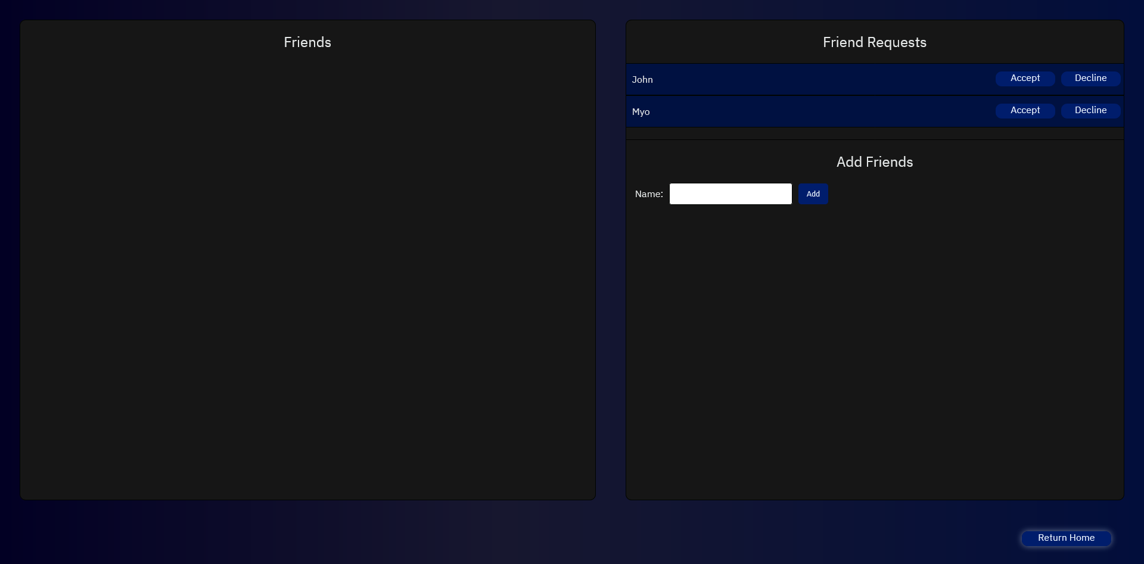

Figure 5.10

# **6.Achievements**

You will be redirected to the ‘Achievements’ page when you click on ‘Show achievements’ on the home page.



You can see your current achievements there and use the ‘Refresh achievements’ link to refresh the page and see new achievements show up if you have obtained them.



# **7.Global Leaderboard**

You will be redirected to the ‘Global Leaderboard’ page (Figure 7.2) when you click on ‘VIEW GLOBAL LEADERBOARD’ (Figure 7.1) link on the home page/ dashboard. There you can see the top 5 users of the system, ranked by the number of courses they have completed.

Figure 7.1

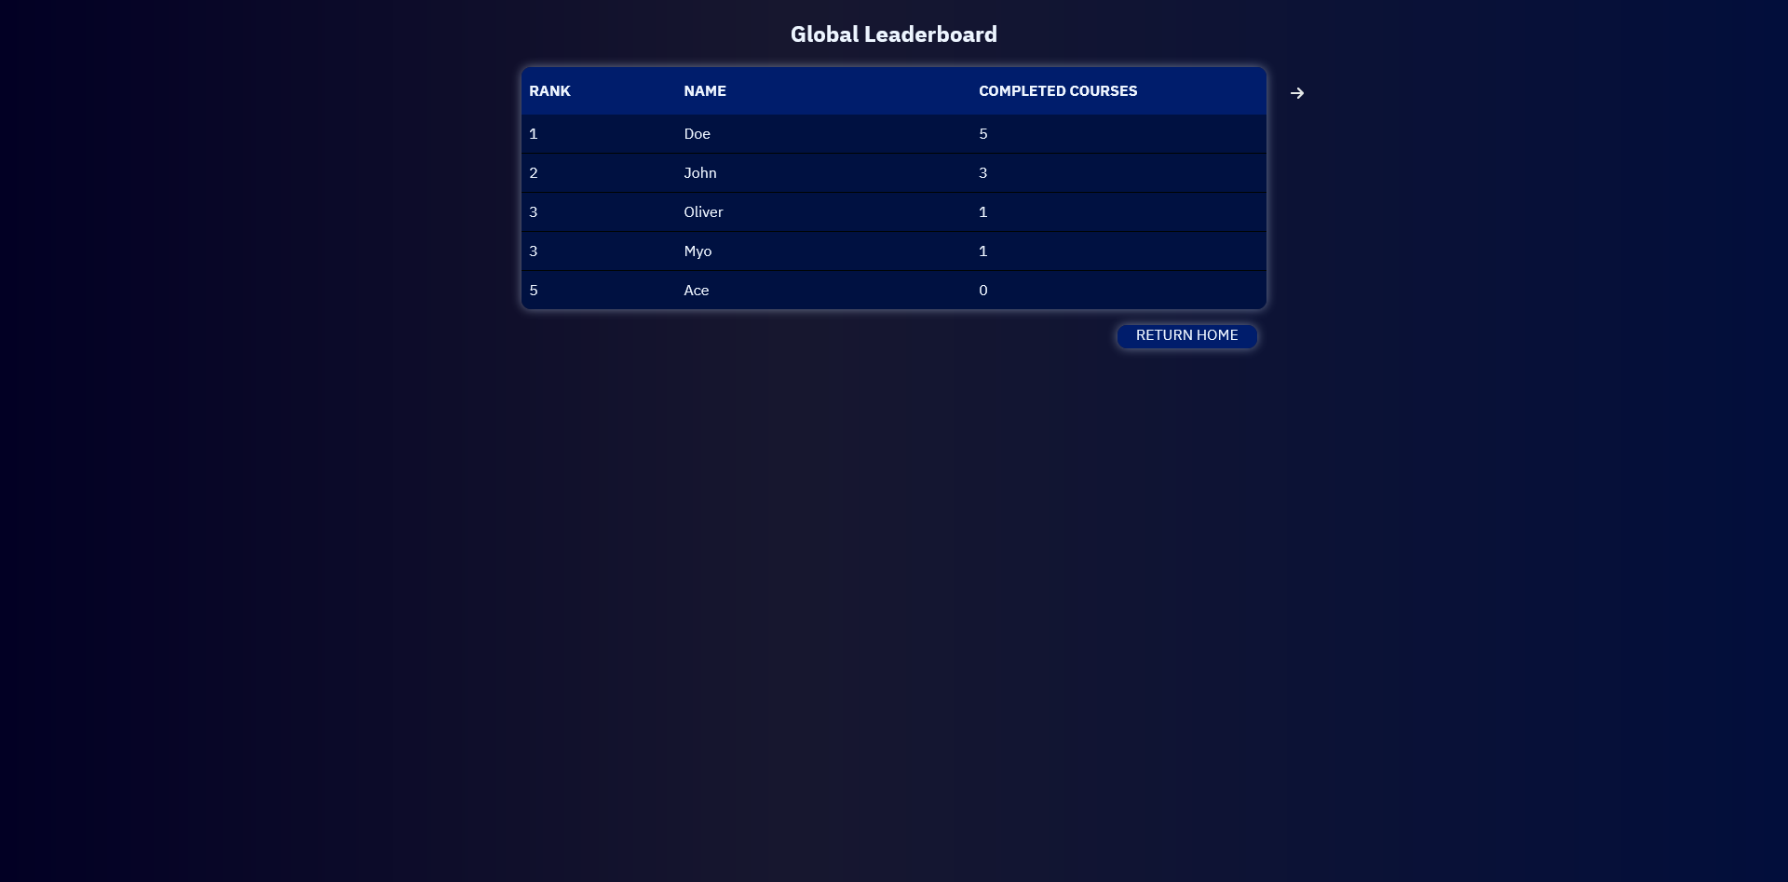

Figure 7.2

## 7.1 Changing the Ranking Factor of the Global Leaderboard

By default, the leaderboard is ranked by the number of courses users have completed. You can change it to be ranked by the number of achievements users have obtained.

### 7.1.1 Changing the Ranking Factor to Achievements

To change the global leaderboard to show achievements, follow these steps:

* Click on the ‘Arrow' button on the top right of the leaderboard.
* Then you can see the changes to the leaderboard.

Figure 7.3

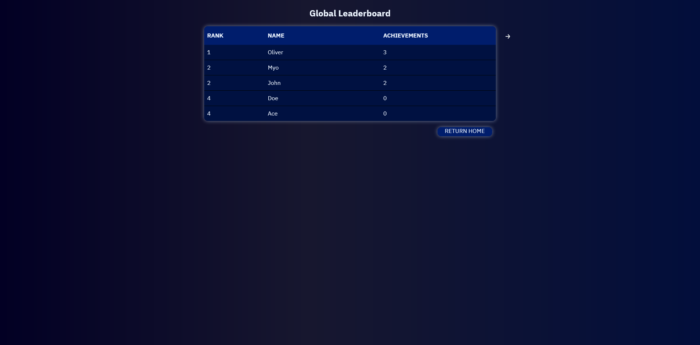

Figure 7.4

### 7.1.2 Changing the Ranking Factor Back to Courses Completed

To change the global leaderboard to show number of completed courses, follow these steps:

* Click on the ‘Arrow' button on the top right of the leaderboard.
* Then you can see the changes to the leaderboard.

Figure 7.5



Figure 7.6